Project Plan
ID: 14648355
Name: mingsen hua

Table
Topic | Questions | Answers
Goal | What is goal of the  website? | Eager on to enlarge the business-size by promoting the existing services  offered by the company and increasing the amount of the short, even long-term business partnership.
Target  Audience | Describe the target  audience (age, gender,  demographics) | focus on local residents, mostly at a age range between 18 and 45, as this group forms the majority of our current  audience or target (mature age job seekers).
Graphics | What graphics will you use  on the website? | Professional photos of training sessions, icons for company, and trainer portraits as a template.
Colour | What colours will you use  within the site to enhance  the purpose and brand? | deep blue background for trust, light gray text for readability, and orange or yellow block for calls-to-action.
Accessibility | How will the website  accommodate people with  disabilities? | Provide alter-link text for all images, high-contrast colour scheme, touch screen with blocks and will playing voice, etc-eta.

Goal
Eager on to enlarge the business-size by promoting the existing services
offered by the company and increasing the amount of the short, even long-term business partnership.

Success Evaluation
The website should produce an increase of local customers of at least 40%.

Target Audience
focus on local residents, mostly at a age range between 18 and 45, as this group forms the majority of our current
audience or target (mature age job seekers).

Site Flowchart

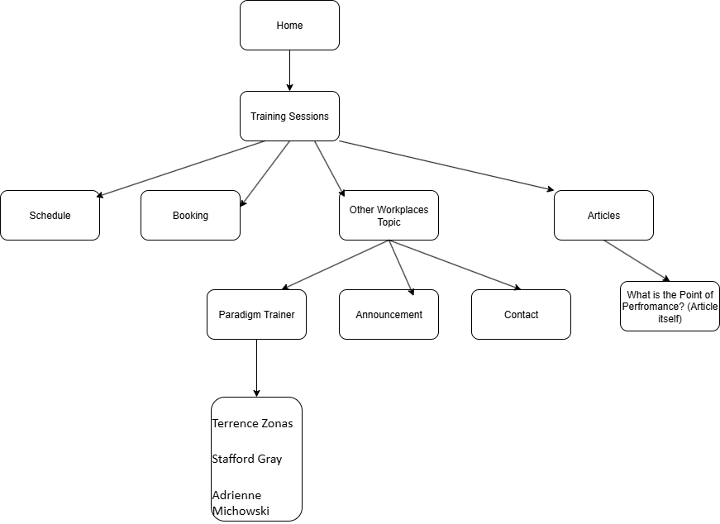

Wireframe (Home Page)
